**Lo-Fi Prototype Report**

**Value Proposition**

Learn to cook healthy and easy recipes.

**Problem Overview**

Many people and more specifically university students never had the opportunity to learn how to cook. Furthermore, people find difficulties to cook food based on a particular dietary restriction.

Due to work and studying the majority of people have no time to cook complicated food that take time.

**Solution Overview**

The website is the solution for cooking, as it allows the user to cook anything that they personally like in a simple way.

**Sketches (Brainstorming)**

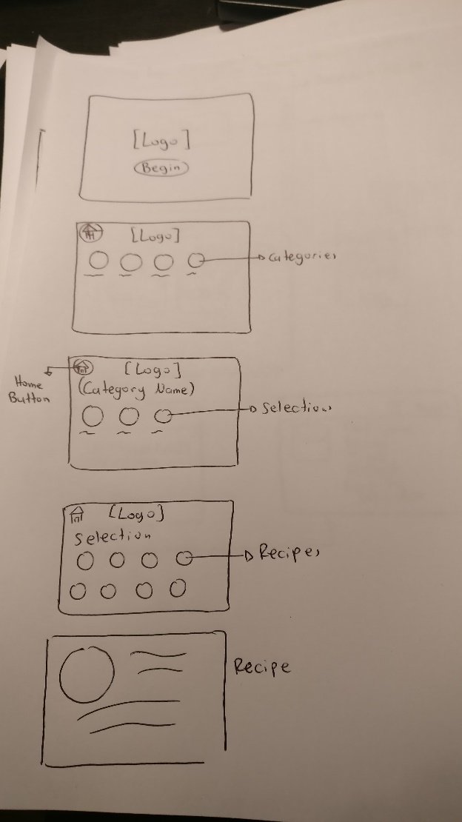

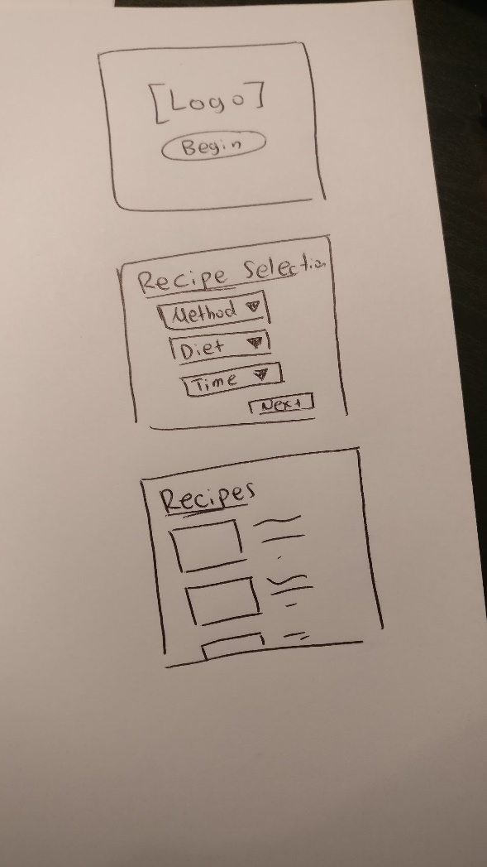

*Figure 1 Figure 2*

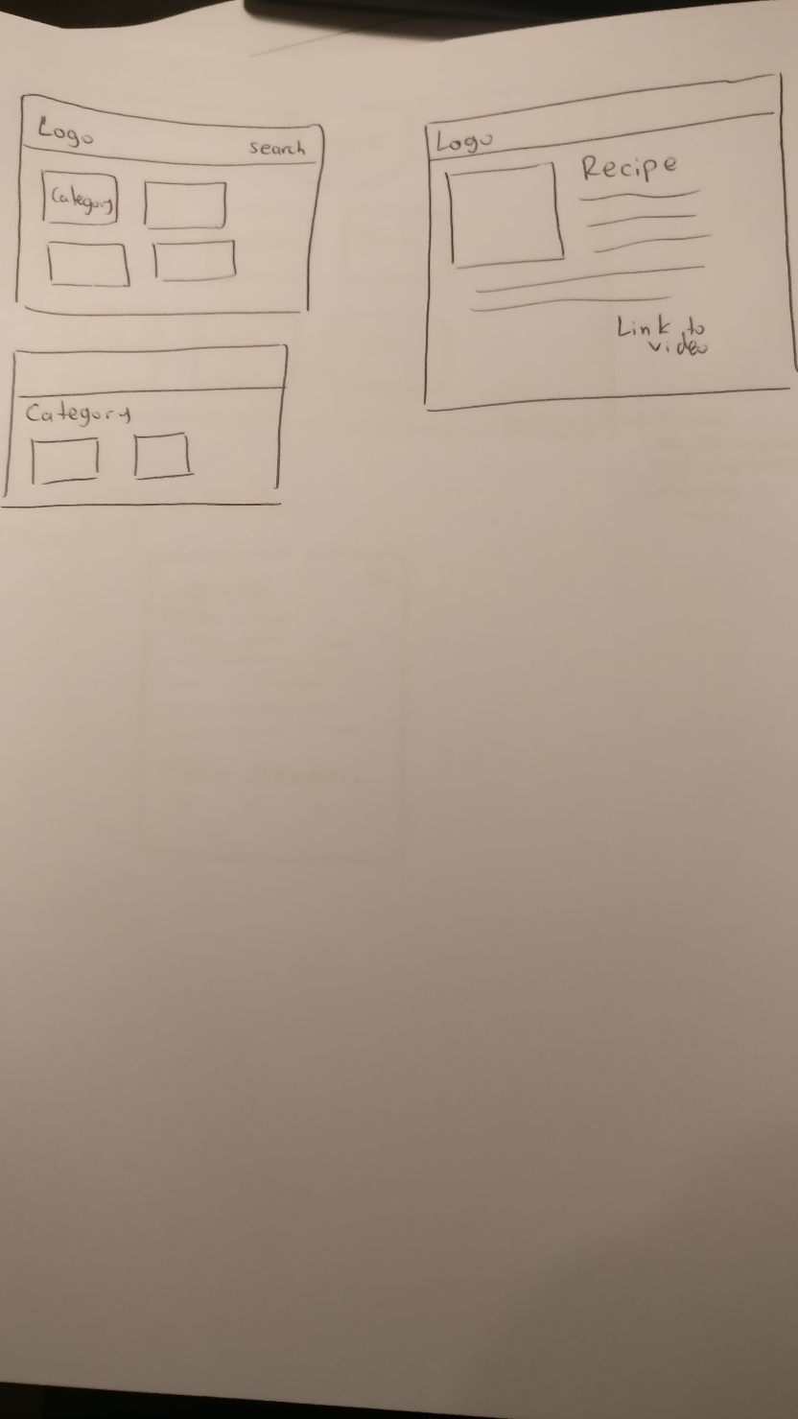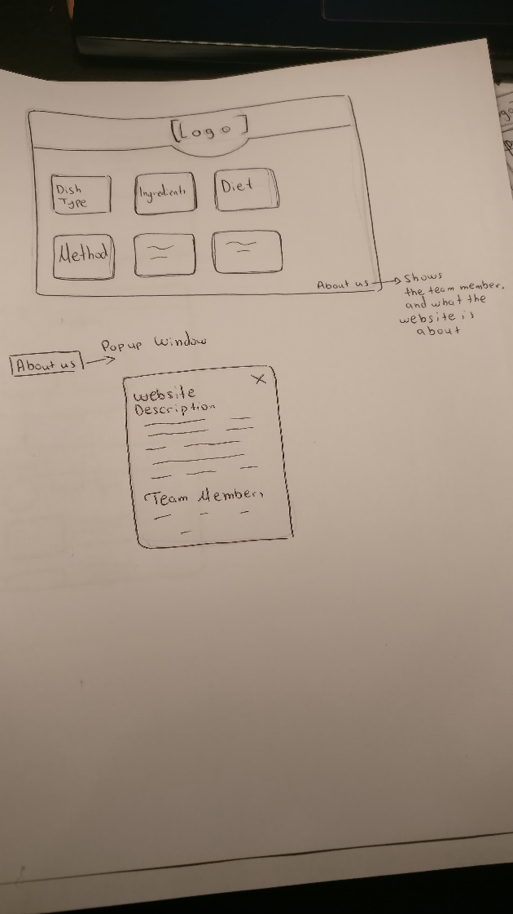

*Figure 3 Figure 4*

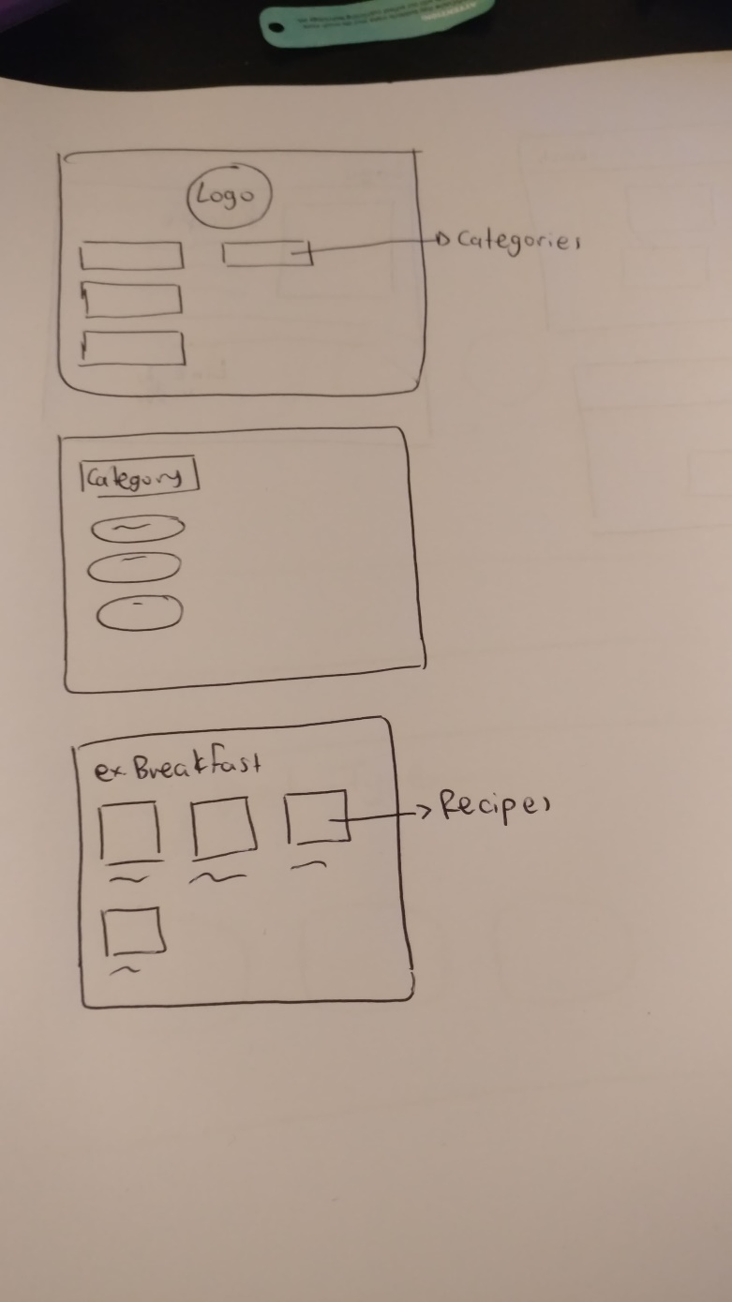

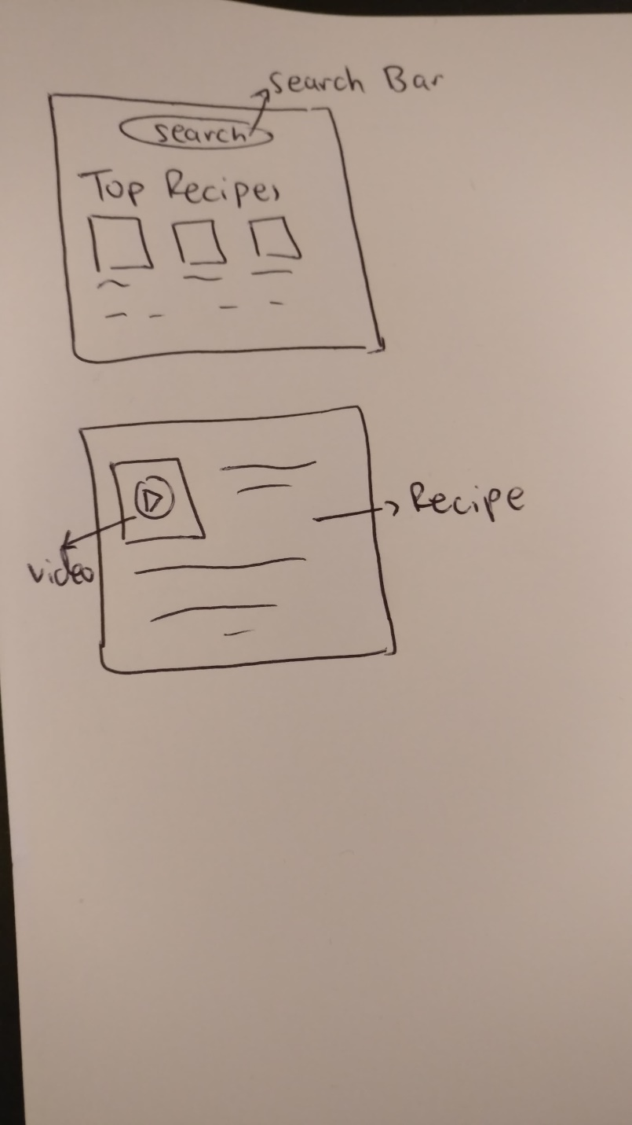

Figure 5 Figure 6

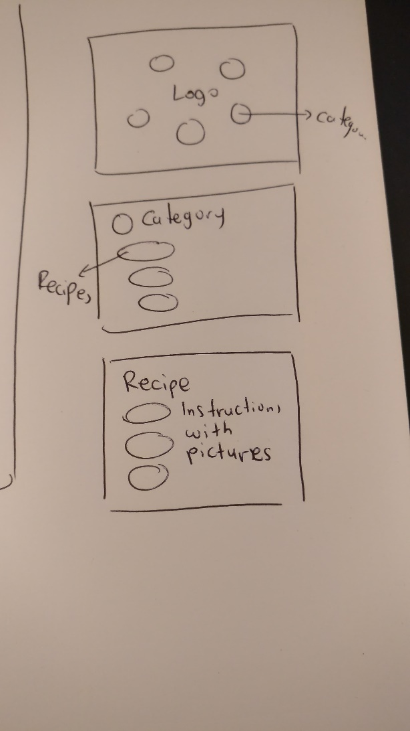

*Figure 7*

By taking all the Figures into consideration, the brainstorming helped our team to generate ideas and create a design which is as simple and interesting to the users as possible.

**Top Two Designs**

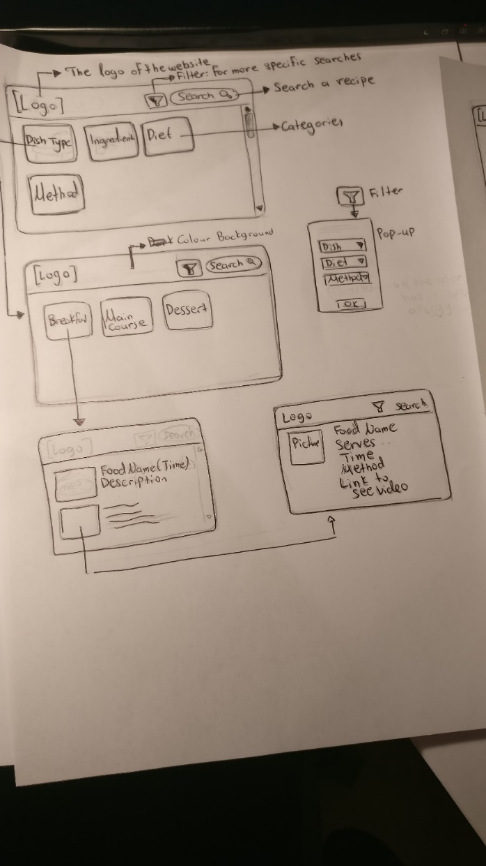

*Design 1*

***Pros:*** *Understandable*

*Easy to Search for a recipe*

*Simple Design*

***Cons****: Maybe too simple*

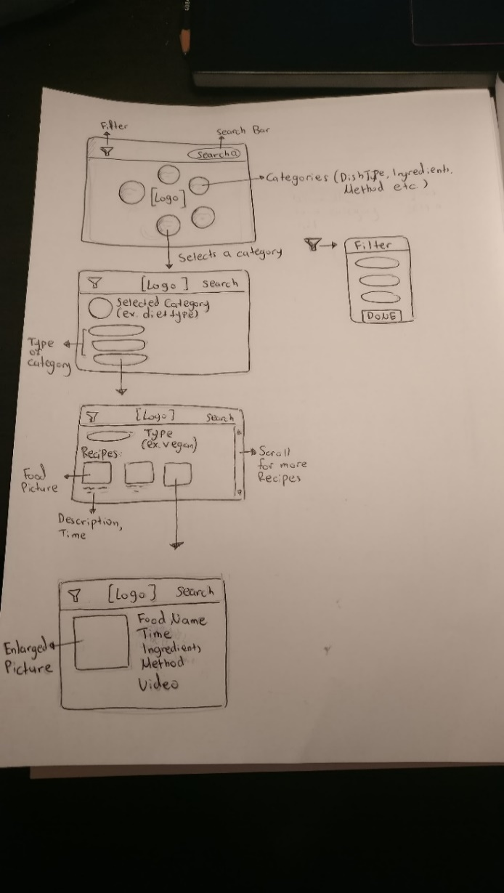*Design 2*

***Pros:*** *Design is more appealing at the first picture*

***Cons:*** *Too complicated UI*

From the various designs that has been created, the decision was common from the group, that the Figure 3 and Figure 7 from the sketches are more interesting to be designed as a website. Both of them has been re-designed to be more understandable.

Design 1 has been decided to be the main prototype as it is more understandable and easier to use. Moreover, the website is designed for everyone, so if it is complicated to use then no one will be interested to use it.

**Task Flow Storyboard**

**Task 1**: Learn About us

When a user wants to learn About us, a pop-up window appears which have details about the website and the team members.

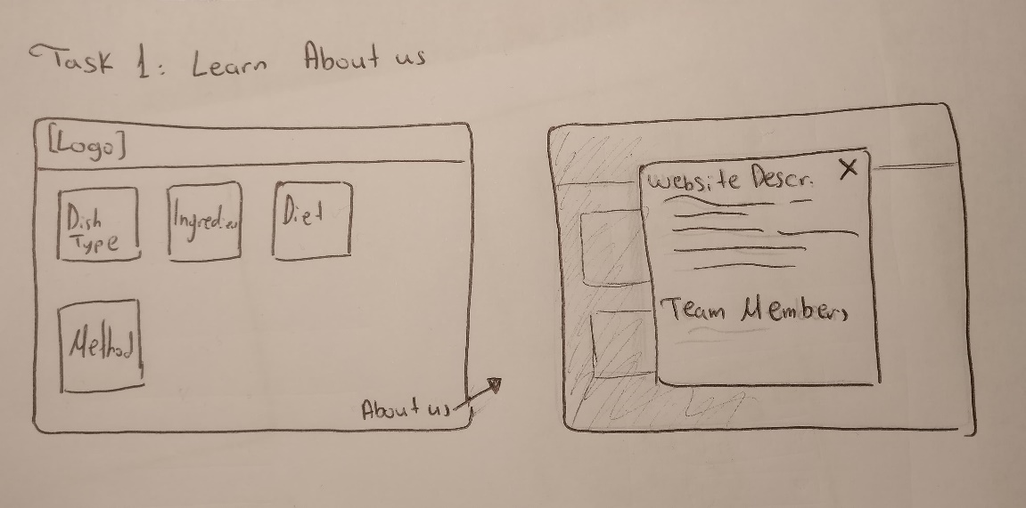

**Task 2:** Select a Recipe based on Diet

A user is vegan and tries to find all the vegan recipes. First, they select Diet Type. Secondly, Vegan selection has been made with the result of all the Vegan recipes to be shown in the website. When a recipe has been selected, all the instructions are written. Furthermore, a link to a video instruction is available and also the details of the creator of the recipe.

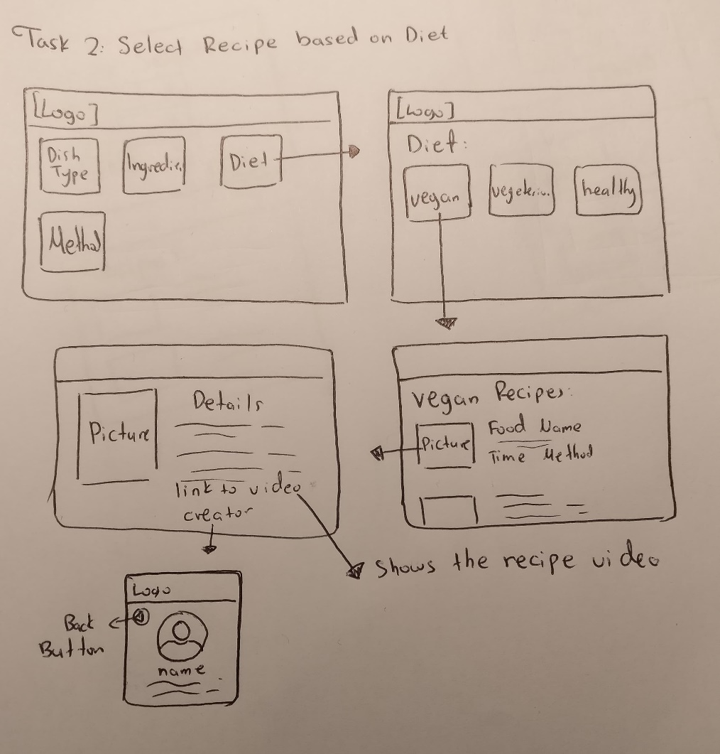

**Task 3:** Select a more specific Recipe (use search bar)

When a user wants to search something specific, the search bar can be used. If the recipe exist then several results will show up on the screen.

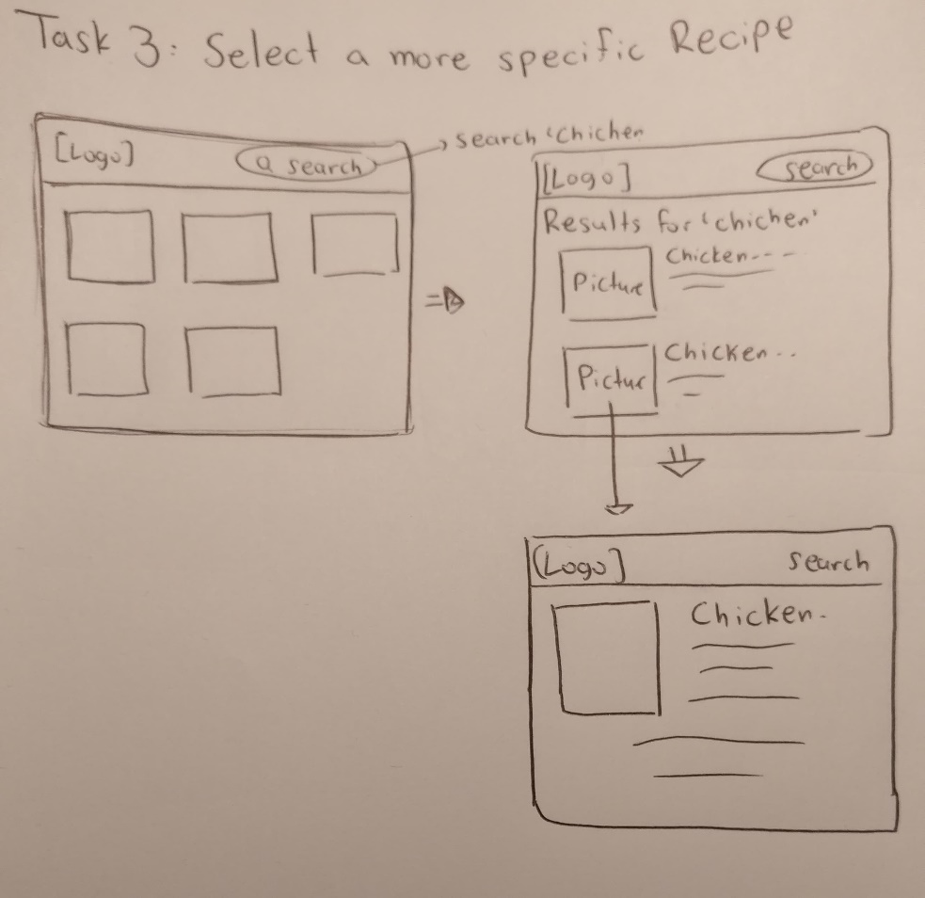

**Lo-Fi Prototype:**

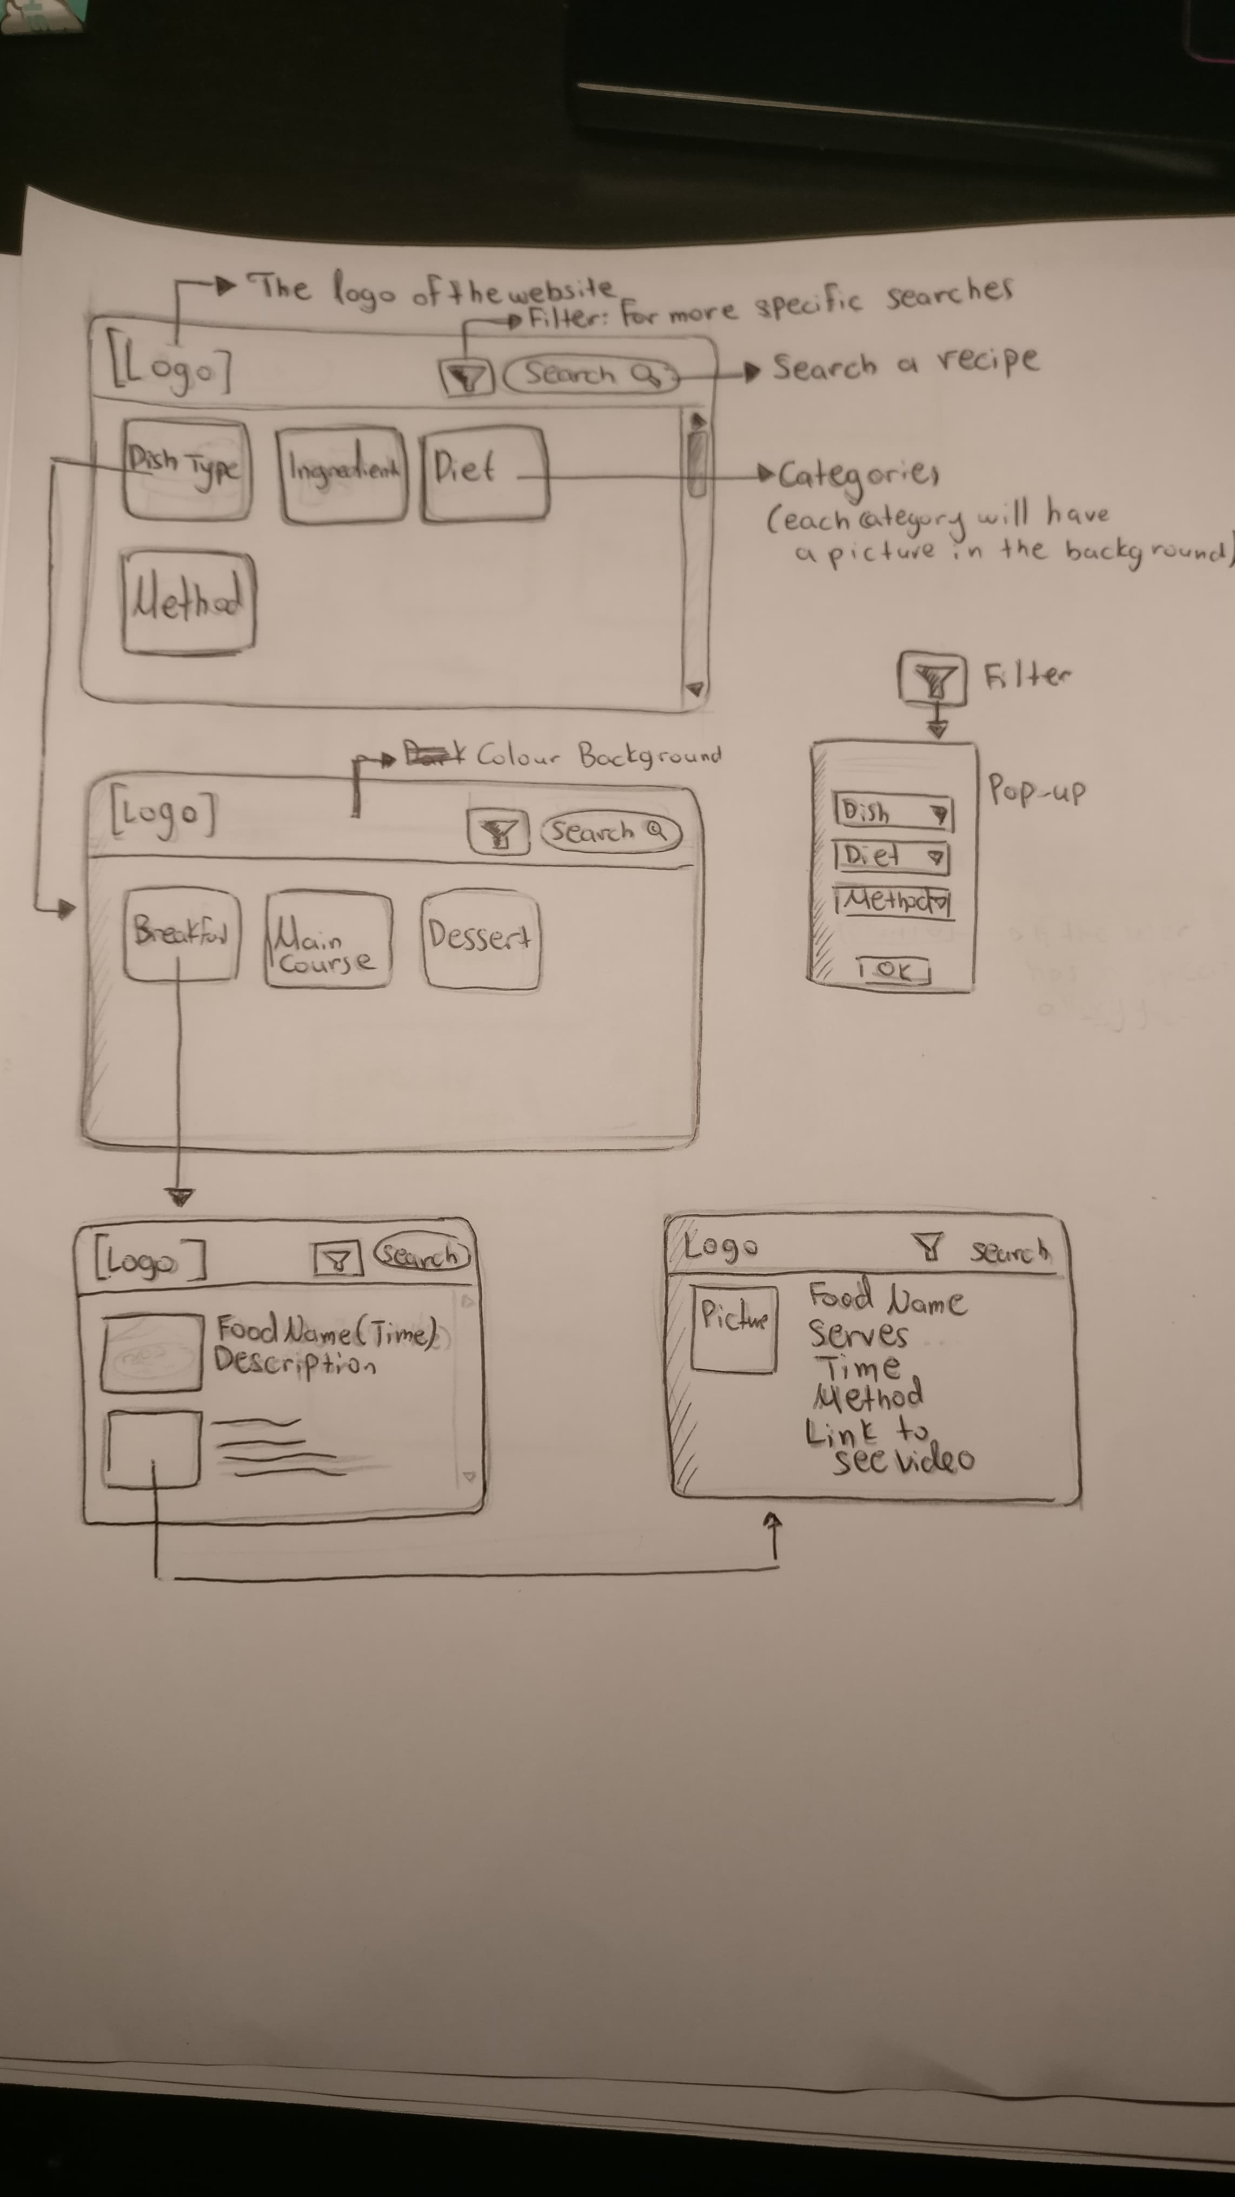

Testing the prototype with the users:

Participants: The target of the participants which has been selected are university students.

The participants have been asked to do simple tasks as for example search for a specific website, learn about the website’s description, see the chef who created a recipe and use the choices. The general procedure would be to show the website in front of them with the task descriptions. Their performance has been measured by noticing how they reacted and how they talked about the website. All the data may have affected our data in a positive way.

Environment: All the participants were asked in their home, with the result of being more comfortable and confident to tell us their honest answer about the website.

Procedure: The low-fi prototypes have been used for the experiment.

Results:

All the participants were satisfied about the website and clearly understood how it worked. The participants understood how to navigate and explore it without any difficulty. Furthermore, one participant seemed to have trouble of going back, as a back button or a home button that takes you to the start does not exist.

Discussion:

Overall, the design is intuitive, simplistic and easy enough to use. However, there are some improvements that can be made in the layout of the website. Furthermore, the participants wanted various ways to search for a website. In the final design, some buttons will be added, as well as an improvement of the design.

Appendices:

The website has been produced for the Human Computer Interaction Course at University of Reading. Participants provide data that is used to evaluate and modify the recipe website. Data will be collected.

Participation in the experiment is voluntary. Moreover, participants will maintained anonymous.

I acknowledge that I have read and understood the consent form for the experiment. I have given time to tell my opinion and ask questions about the website. I also accept that my opinions might be published.

Name: ____________________________

Date: _____________________________

Participant Signature: ________________________